
School of Computer Science and Engineering
Fall Semester 2024-25
CAT I – ANSWER KEY
SLOT: E1
Programme Name & Branch: B.E Computer Science and Engineering / SCOPE
Course Name & Code: BSCE306L / Artificial Intelligence
S.No. | Answers | Marks
1. | Scenario 1: Customer Browsing an Online Shopping Website  Performance Measure: Maximize customer satisfaction (e.g., find desired products, easy checkout process, secure transactions).  Environment: Semi-dynamic, discrete, multi-agent (other customers, website administrators).  Actuators: Clicking on links, adding items to cart, entering payment information.  Sensors: Visual information (website layout, product images), textual information (product descriptions, reviews).  Scenario 2: Chatbot Customer Service  Performance Measure: Resolve customer inquiries effectively and efficiently.  Environment: Semi-dynamic, discrete, multi-agent (other customers, human customer service agents).  Actuators: Textual responses to customer queries.  Sensors: Textual input from customers.  Scenario 3: Home Automation System  Performance Measure: Maximize user comfort and convenience (e.g., control temperature, lighting, appliances).  Environment: Semi-dynamic, continuous, single-agent.  Actuators: Control devices (thermostats, lights, appliances).  Sensors: Temperature sensors, light sensors, motion sensors.  TYPES OF ENVIRONMENTS  Scenario 1: Customer Browsing an Online Shopping Website  partially observable, semi-dynamic, discrete, multi-agent, partially observable, stochastic, competitive, and sequential.  Scenario 2: Chatbot Customer Service  partially observable, semi-dynamic, discrete, multi-agent, partially observable, stochastic, and sequential.  Scenario 3: Home Automation System  fully observable, semi-dynamic, continuous, single-agent, deterministic, known, and sequential. | 10
2.a | Anomaly Detection: AI algorithms can identify unusual patterns in transaction data that may indicate fraudulent activity. For example, large, unusual transactions or sudden changes in spending habits can be red flags.  Behavioral Analytics: AI can analyze customer behavior patterns to detect anomalies. For instance, if a customer suddenly starts making large international transfers or purchases unusual items, it could be a sign of fraudulent activity.  Transaction Monitoring: AI can continuously monitor transactions for suspicious patterns that might indicate money laundering activities. This includes identifying transactions that appear to be structured to avoid detection or those involving high-risk jurisdictions.  Network Analysis: AI can analyze the relationships between individuals, businesses, and accounts to identify potential money laundering networks. By mapping these networks, banks can detect suspicious connections and investigate further.  Risk Scoring: AI can assign risk scores to customers and transactions based on various factors, including transaction history, customer behavior, and external data. This helps banks prioritize investigations and allocate resources effectively. | 5
2.b | How Expert Systems Work  - Knowledge Acquisition  - Inference Engine  - User Interface  One example (A Medical Diagnosis Expert System) | 5
3. | Path: B → C → E → J  Cost: (3+5+5) + 0 = 13  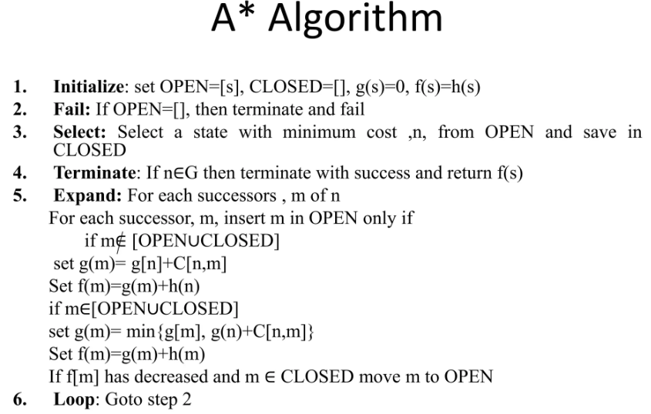 | 10
4.a | Initial: 8x8 chess board  Actions: horizontally, vertically, or diagonally.  Goal cost: 8 queens should be placed in the chessboard such that no queen can attack another  Path cost: Cumulative cost of each action when placing a queen in the board (usually assumed to be 1 per action). | 5
4.b | DFS: A -> B -> D -> F -> E -> C -> G  IDS:  Level 0: A  Level 1: A -> B -> C -> E  Level 2: A -> B -> D -> F -> C -> G | 5
5. | Hill Climbing  Hill climbing is a simple optimization algorithm that iteratively moves towards a higher-valued solution. In the context of manufacturing scheduling, the "value" could be a combination of factors like production time, resource utilization, and cost.  Steps:  - Generate an initial schedule  - Evaluate the schedule  - Explore neighbors  - Select the best neighbor  - Repeat  Potential Obstacles:  - Local optima  - Plateaus  Simulated Annealing  Simulated annealing is a more robust optimization technique that allows for occasional "uphill" moves, helping to avoid local optima. It is inspired by the annealing process in metallurgy, where a material is heated and then slowly cooled to reach a low-energy state.  Steps:  - Generate an initial schedule.  - Evaluate the schedule.  - Explore neighbors.  - Select the best neighbor.  - Accept or reject:  - If the new schedule has a higher value, accept it.  - If the new schedule has a lower value, accept it with a probability that decreases over time (simulating cooling). This probability is determined by a temperature parameter.  - Update temperature: Gradually decrease the temperature parameter.  - Repeat steps 3-6 until the temperature reaches a predefined minimum or a satisfactory solution is found.  Advantages of Simulated Annealing:  - Escaping local optima  - Flexibility | 10

